**EXP -5**

**DATE : 09-02-2023**

**DEMONSTRATE INFRASTRUCTURE AS A SERVICE(IAAS) BY CREATING A VIRTUAL MACHINE USING A PUBLIC CLOUD SERVICE (AZURE)**

**AIM:**

To demonstrate infrastructure as a service (Iaas) by creating a virtual machine using a public cloud service (azure)

**PROCEDURE:**

1. Create an account in microsoft azure.
2. Goto resource group and create a resource group.
3. Give necessary things for resource group
4. Create a virtual network for to create a virtual machine .
5. Now create a virtual machine with ur ip address an username and password for your virtual macine.
6. Your virtual machine is deployed.
7. Now connect the virtual machine and download the rdp file to open your windows virtual machine.
8. Created a new windows virtual machine.

**IMPLEMENTATION:**

**STEP1:CREATE AN ACCOUNT IN MICROSOFT AZURE.**

**STEP2: GOTO RESOURCE GROUP AND CREATE A RESOURCE GROUP.**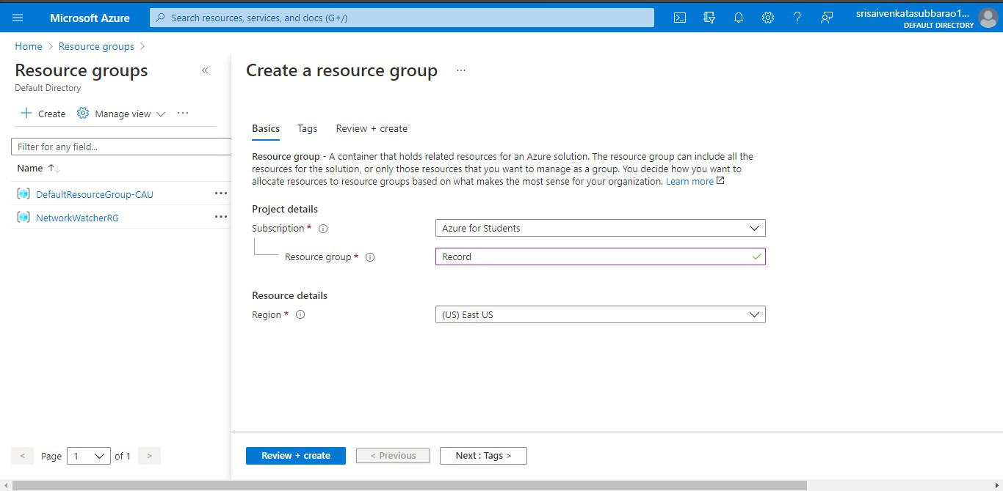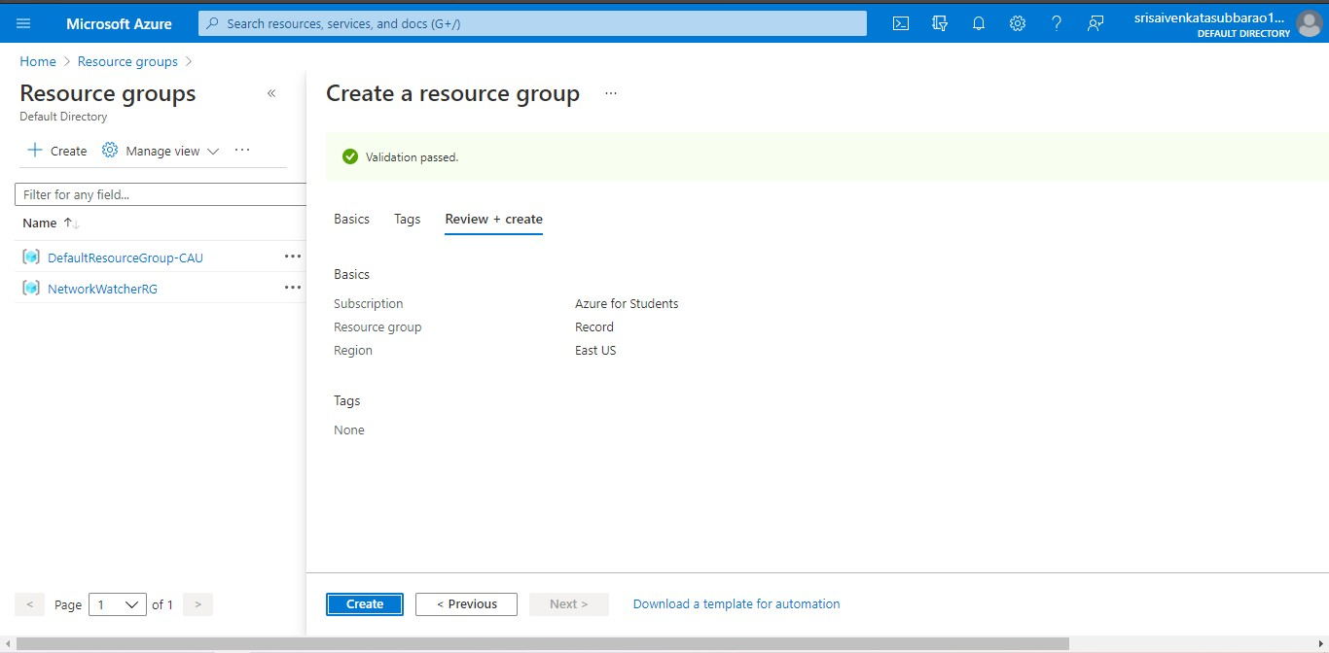

**STEP4: CREATE A VIRTUAL NETWORK FOR TO CREATE A VIRTUAL MACHINE .**

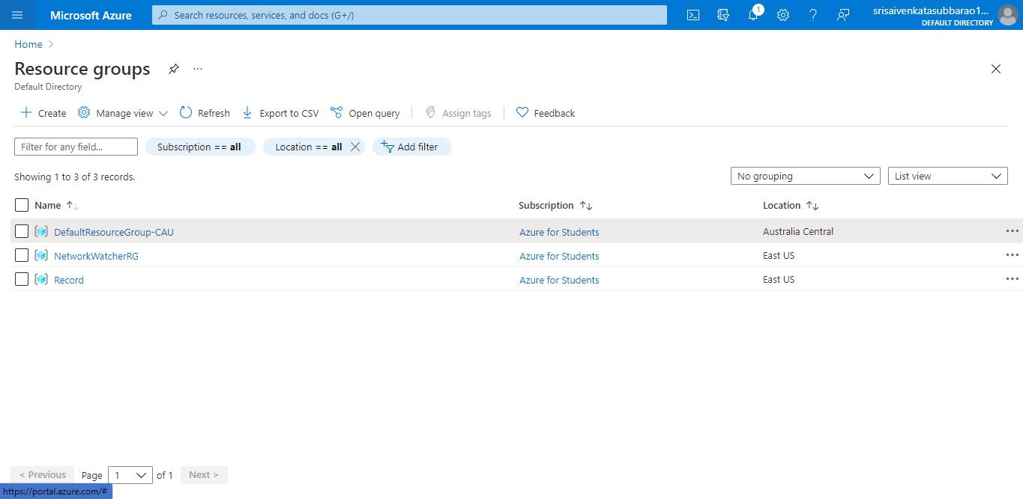

**STEP5: NOW CREATE A VIRTUAL MACHINE WITH UR IP ADDRESS AN USERNAME AND PASSWORD FOR YOUR VIRTUAL MACINE.**

**STEP6: AND YOUR VIRTUAL MACHINE IS DEPLOYED.**

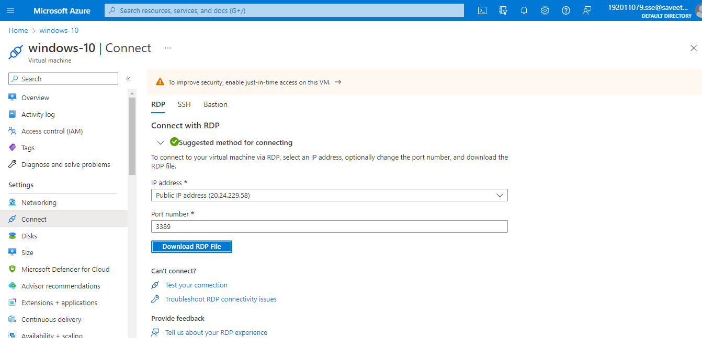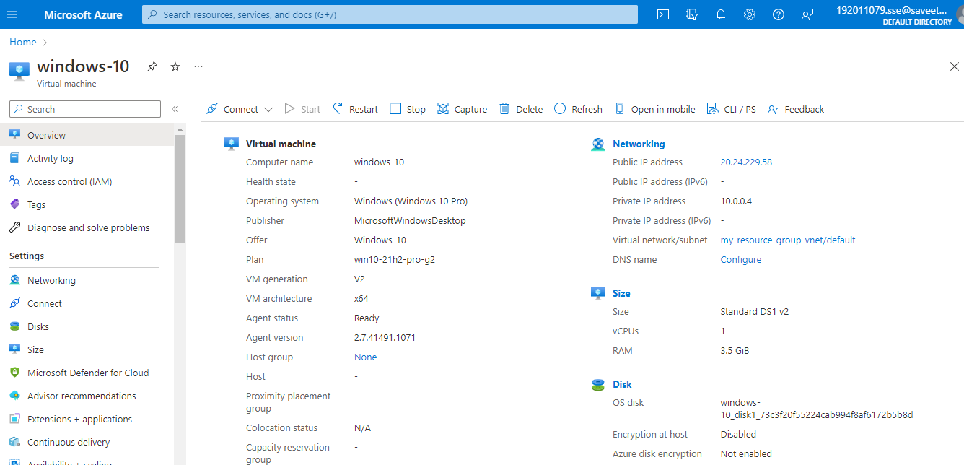

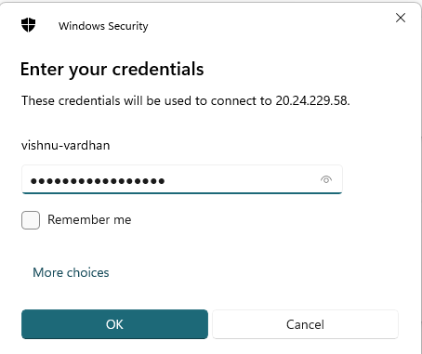**STEP7: NOW CONNECT THE VIRTUAL MACHINE AND DOWNLOAD THE RDP FILE TO OPEN YOUR WINDOWS VIRTUAL MACHINE.**

**STEP8: CREATED A NEW WINDOWS VIRTUAL MACHINE.**



**RESULT:**

Hence infrastructure as a service (Iaas) by creating a virtual machine using a public cloud service (azure) is Demonstrated.